Funds Without Coordination: What Offshore Wind Reveals About the Missing Ingredient in the Growth and Skills Levy

By: Yusra Hussain
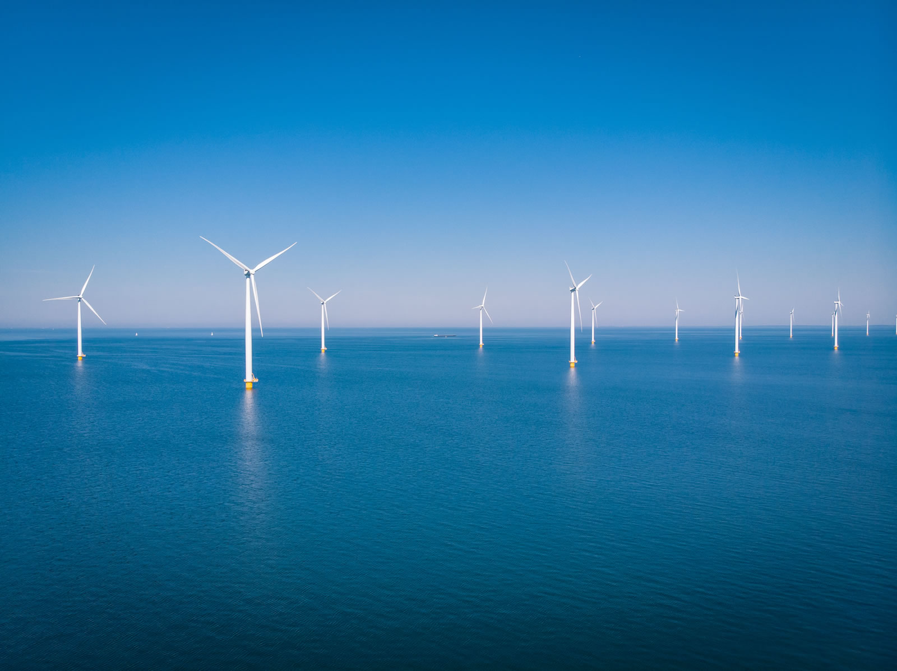Dogger Bank Wind Farm - The World's Largest Offshore Wind Farm - Photo by: doggerbank.com
"We have a lot in our pot. I think there's an excess of £1,000,000 in there. So it's not always easy to use the apprenticeship levy."
I heard this in an interview with a learning and development lead at one of the UK's largest offshore wind developers, and I remember pausing before my next question. I'd expected to talk about scarcity — that was the story I'd absorbed from every energy transition I'd read about. Instead, she was telling me about a million pounds sitting untouched, set aside for training turbine technicians and electrical engineers, that her organisation couldn't work out how to spend.
A few weeks later a manufacturer further down the same supply chain described the opposite problem: running through their levy funds faster than expected, and looking at co-funding training themselves. The same policy was producing two entirely different realities within the same sector.
Two energy worlds of my own
I came to this research with two energy backgrounds behind me: Pakistan, a developing country dependent on fossil fuels, where apprenticeships are not a familiar route into industry, and oil and gas, where workforce planning was resourced and centralised as a matter of course. For my MSc dissertation, I looked at offshore wind in North East England — in the UK, a developed country and home to the world's biggest offshore wind farm — and asked what a transition into renewables looks like once you get past the turbines and targets, down into the training systems meant to staff it.
Can the Apprenticeship Levy, now reformed into the Growth and Skills Levy, deliver the workforce that net zero and projects like Dogger Bank need? I assumed the answer would be about funding, but I was wrong.
I tested this in front of the sector itself, presenting early findings to the Investment in Talent Group at the Offshore Wind Industry Council. Developers, supply chain firms and government officials recognised the problem quickly: the levy was confusing, unevenly used and difficult to coordinate. What landed differently was my proposed fix — a broker for offshore wind that could hold onto both unspent funds and trained people when projects ended.
Tools hidden in plain sight
There's a levy mechanism called the Flexi-Job Apprenticeship Agency model, built to let apprentices move between employers rather than being tied to one — exactly the flexibility offshore wind seems to want. I asked the person managing levy funds at a major developer whether they used it.
"I've never heard of that now."
A policy lead explained why: "There's no guarantee that they're going to come and work [for them]." The firms, she said, worried about competition seeing who they had trained. It reminded me that one policy does not fit every sector. A mechanism designed for exactly the mobility problem I kept hearing about was sitting unused, because no firm could be confident it would see a return on training someone who might leave for a competitor. Not a design problem, then, but a trust problem — and, at times, an awareness problem too. Other support mechanisms seemed to disappear beneath the everyday difficulty of understanding the levy itself.

From goodwill to coordination
Anthropology trains you to notice what people do not do, not just what they say. The same pattern kept showing up across my interviews: everyone agreed collaboration was necessary, and almost no one could make it happen alone. At the same time, regional authorities showed what coordination could look like in practice by making better use of the same levy funds. One person brokering levy funds between a carbon-intensive energy company and a regional college put it simply: "We don't mind then if they do offshore or whatever they want to do. We just want to make sure they have got a positive destination."
That was a genuine instinct, but it also told me something about the system: funding moved only where someone's goodwill filled a gap that policy had not closed. I saw the same thing at a Durham Energy Council event, where civic and policy actors set out a shared regional agenda. When that effort later reached the Secretary of State's desk, it struck me how much coordination comes down to whether a local concern finds a route into a bigger conversation, or simply stays put.
Better questions than I started with
I began this dissertation assuming that a developed country with a net zero agenda and a world-leading offshore wind infrastructure would have a more settled way of planning the workforce behind it. The evidence changed that assumption. I did not finish by arguing simply for more money, because the problem was not financial. What I found instead was a missing ingredient in the skills ecosystem: “coordination capacity”. Turbines and targets get most of the attention in this transition. What I came away caring about was quieter, but no less important: whether the people who already understand the problem can become the ones who fix it.

