Hopeful Heritage: Collective Memory of the Industrial Past Through Mining Banners in County Durham, UK
2025–2026 Dissertation Blog Award Submission
Meg Albanese
Questions
Upon arriving in Durham, I realised that the history of County Durham was one of industry, specifically of coal. I grew interested in how, despite the difficult history of the industry—rife with strikes, disasters, and mine closures—the legacy lives on. In my research, I disentangled ways in which collective memories of the mining industry are facilitated specifically through mining banners, and in return, how banners reflect a communal vision of the past. I was initially interested in ‘contested’ cultural heritage; specific instances where dissonance in historical understandings and narratives exist. However, I quickly realised I was approaching the topic through the wrong lens, one that assumed a categorical difference between heritage that is and is not contested. Rather, all heritage can be argued to be ‘contested’ in one way or another, as cultural heritage intrinsically shapes and is shaped by collective identity and memory. In other words, heritage is a social process, where its continuity involves active human involvement and choice. Through ethnographic fieldwork, I paid attention to how continuity and community are sought in mining banners, and how they serve as politically driven, ‘hopeful’ actors today. For instance, I discuss banners as ‘art,’ and how the community-oriented reproduction of banners reconfigures history and culminates different perspectives to find a cohesive trajectory between the past, present, and future of the village.
Mining Banners Displayed at Redhills in County Durham
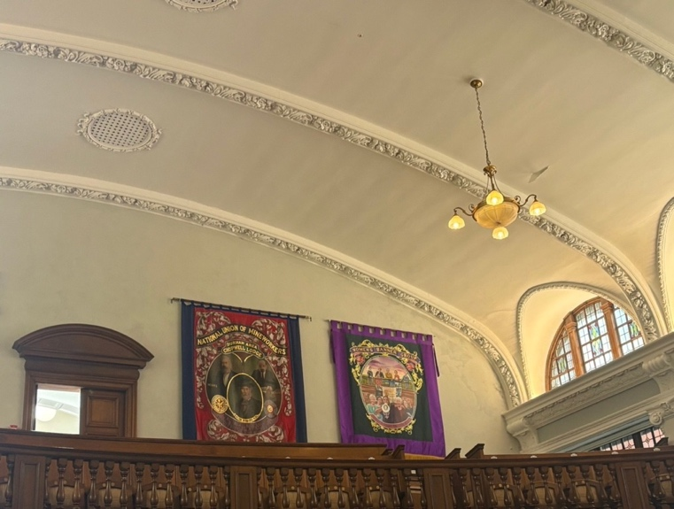
Fieldwork
At the beginning of my fieldwork, I approached potential participants online, including banner groups and banner artists. I faced some difficulties in finding participants, as this process limited the scope to those with an online presence. However, once I was able to communicate with some participants, they invited and introduced me to the wider community. Throughout fieldwork, I engaged with participants who had kindly and generously shared stories and experiences about their memories, their community and family’s history, and their perspectives on the banners that I would not have had the privilege to know about otherwise. A banner group that I approached kindly invited me to march with them at the Durham Miners’ Gala—an annual celebration of mining heritage—and this was one of the highlights of my fieldwork.
Interestingly, some participants had told me that they were happy to participate in the research, as they wanted their stories “written down.” This became an important reminder to me of the responsibility of representing their perspectives. I also became aware of some limitations in relation to my positionality. As an outsider to the topic and region, there were certain efforts on the part of the participants where some terminology and contexts had to be further clarified. I also anticipate cultural nuances that I was unable to catch, which may, for example, affect what was noted in field observations and analysis. However, being aware of the limitations, I wanted to do my best to capture, to the best of my ability, the particular moment in time from an anthropological perspective.
Findings and further questions
In my research, I discussed how, in different ways, mining banners serve as a process of reassembling the past in order to foster historical continuity, as well as a sense of community. Banners often represented a legacy of the miners, specifically of the difficult history of struggle, and the idea that the community’s predecessors had fought for a better, more hopeful future. I learned that in trying to answer questions in research, I was often left with more. For example, in answering my question on how collective memory of the mining industry is formed through heritage, I thought that the concept of nostalgia could be useful. However, this left me with a methodological dilemma. In the literature, nostalgia is understood as a widely applicable binary that is either regressive and reactionary or being akin to progressive values that critically engage with the past. But during fieldwork, I observed that the community often specifically associated nostalgia with the former, as a reductive attitude towards the past. With the dissonance between how the concept is understood academically and in the field, I was left with questions about how this should be ethnographically applied. Though I am not sure if I reached a concrete conclusion to this question, I was reminded of the importance of ethnographic experiences that allow a critical perspective on existing theories and the status quo. In my research, for instance, ethnographic exploration enabled me to challenge the strict binary conceptualisation of nostalgia. I instead emphasised its complexities and ambiguities in which different forms of historical remembrance co-exist and, further, work with each other. Anthropology, as such, allowed me to never be satisfied with a simple answer; to not take for granted empirical realities that can show a more complicated (and interesting) picture.
Bearpark Lodge Banner at 2026 Miners’ Gala – “Mighty Oaks from Acorns Grow”
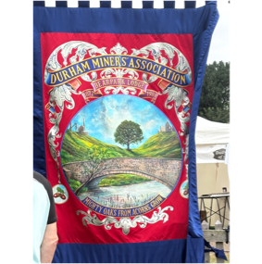
Women’s Banner Group Banner at 2026 Miners’ Gala
