WHAT TO EXPECT ON THE DAY

THE CEREMONY DAY
Congregation (graduation) ceremonies are held in Durham Cathedral with related activities taking place at the Teaching and Learning Centre (including Robing, Photography and the Congregation Fair). It is approximately a 15 – 20 minute walk between the Teaching and Learning Centre and the Cathedral.

- Graduands must report to the Teaching and Learning Centre 2.5 hours before the time of their ceremony and proceed directly to register their attendance and pick up their robes. It is useful if graduands can bring along their campus card to assist with registration on the day.
- Graduands must report to the Great Hall of the Castle by 1 hour and 15 mins prior to their ceremony (i.e. 8:45 am for a 10:00 am ceremony) to allow time to be put into procession order. Please ensure you give yourself plenty of time to get from the Teaching and Learning Centre to the Great Hall. Graduands who do not arrive on time will be excluded from the ceremony.
- Guests will be directed to enter the Cathedral from the Information Point on Palace Green approximately 45 minutes before the ceremony start time and should take advantage of facilities at the Congregation Fair in the Teaching and Learning Centre beforehand.
- Each ceremony confers degrees on around 280 students so it will be busy and there will be queuing. Please be mindful of this when planning your day.
- It is approximately a 20 minute walk from the Teaching and Learning Centre to Palace Green so graduands and guests must allow sufficient time for this. The Congregation Fair is available for graduands and guests to enjoy before and after the ceremony.
- Graduands must give guest tickets and small belongings (A4 size or smaller) to guests before going to the Great Hall in the Castle.
- The ceremony lasts approximately 1 hour.
- Graduates must return robes before 5:30pm to the drop off point in the Teaching and Learning Centre on the day of their ceremony.

VENUES
A map and directions to Durham are published on our website: Location - Durham University

Congregation is located at Durham Cathedral and the Teaching and Learning Centre. Please see below addresses to help you find your way:

Durham Cathedral  Palace Green  Durham  DH1 3RN | Teaching and Learning Centre  Durham University  South Road  Durham  DH1 3LS

PARKING
There is no public parking or vehicle access to Palace Green.

Graduands and guests with mobility issues can be dropped off by car or taxi at the bottom of Owengate. There is also a shuttle bus available from the Teaching and Learning Centre to the Cathedral.

Howlands Park and Ride is situated approximately 500 metres from the Teaching and Learning Centre, and the bus goes past the Centre on its way into the city. See here for more information: Durham City Park and Ride - Durham County Council
Parking in the city will be busy so please allow plenty of time for your journey. Further information can be found at: Parking - Durham County Council

Note that Palace Green lies within the city congestion charge zone: Durham Peninsula charging zone - Durham County Council

CONGREGATION INFORMATION POINTS
There are two Congregation Information Points at Winter Congregation. One is located on Palace Green outside of the Music Building and the other is on the ground floor of the Teaching and Learning Centre for general enquiries.

GUEST TICKETS
Guests OR graduands can collect tickets on the day of the ceremony (only tickets for that day’s ceremonies will be available to collect) from the Guest Ticket Desk in the Teaching and Learning Centre. We recommend for guests to collect tickets to ensure graduands have enough time to get their robes and make their way to the Castle.

10:00 am ceremony from 7:45 am
12:00 noon ceremony from 9:45 am
3:00 pm ceremony from 12:00 noon

Tickets are strictly non-transferable and are allocated to the graduand. Once tickets have been collected, they are the responsibility of the graduand, and we cannot replace lost tickets.

Guests without tickets can watch the live stream which takes place in a lecture theatre in the Teaching and Learning Centre.

Please be aware that due to the number of students/ guests collecting tickets, there will be queues and we thank you in advance for your patience.

GUEST ENTRANCE INFORMATION
Guests, with tickets, queue at the Information Point on Palace Green approximately 45 minutes before the ceremony start time and will be escorted into the Cathedral via the Galilee Chapel. Guests are seated separately from graduands. Guests who wish to sit together should arrive together.

There is no shelter outside the Cathedral, and it can be extremely cold in winter, so guests are advised to dress accordingly.

Guests may have to wait at the Galilee Chapel for a short period until the venue is ready. Guests without tickets can watch the live stream which takes place in a lecture theatre in the Teaching and Learning Centre.

Guests must have a ticket to enter the Cathedral; these will be checked upon entrance to the Galilee Chapel so should be readily at hand.

On entering the main body of the Cathedral, guests will be guided by marshals to fill all seats from the front to the back, in the Nave and then the Side Aisles.

The view of the stage in the Side Aisles is restricted due to the Cathedral architecture; however, television monitors are installed throughout the Cathedral to enhance the viewing of the ceremony.

During the ceremony graduands names will be called to process across the stage individually, pausing in front of the Presiding Officer to shake hands. The ceremony lasts approximately one hour.

GRADUANDS AND GUESTS WITH SPECIAL REQUIREMENTS
Graduands must advise of any special requirements for themselves or guests when registering for their ceremony on Banner Self Service. Graduands and guests can also contact the Ceremonies Unit directly to discuss any special arrangements if they wish.

Induction loop facilities are available throughout the seating areas in the Cathedral and those who require it should use the ‘T’ position on their hearing aid.

Subtitles are also provided on the screens around the Cathedral and on the live stream. You can also listen to the Live Stream in another language. Please see here: SpeakseeFrontend.

Guests with difficulties with mobility and unable to queue can report to the Congregation Information Point on Palace Green 1 hour and 15 minutes before the ceremony start time (with a companion if they wish) to be escorted into the Galilee Chapel so that you can be seated until the Cathedral is ready.

Guests using wheelchairs can report to the Congregation Information Point on Palace Green 30 minutes before the ceremony start time (with a companion if they wish) to be escorted into the Cathedral via an accessible route.

A bus will be operating between the Teaching and Learning Centre and Palace Green throughout the day for those who require assistance.

Please note, guests with special requirements will be seated in the Font area of the Cathedral for health and safety so they are close to an accessible route.

GUESTS WITH CHILDREN
The ceremony is a formal occasion and can involve a lot of waiting around. Disruptions by small children can disturb the graduands and their guests. Please consider this before bringing a small child along. Tickets are required for children over the age of 2, under 2’s do not require a ticket as they can sit on a guest’s lap.

Children and babies cannot be seated with the graduand, they must be seated with an adult guest in the guest section of the Cathedral. Anyone under the age of 18 must be accompanied by an adult in compliance with our Safeguarding policy Safeguarding Children - Durham University

Pushchairs can be accommodated inside the Cathedral, however, please bear in mind they cannot block the aisles and there are restrictions on personal belongings.

The ceremony is also streamed live to the lecture theatre in the Teaching and Learning Centre which may be more comfortable for guests with small children. All children must be accompanied by an adult.

PHOTOGRAPHY
Photography is not permitted during the ceremony, this includes the use of still, digital and video cameras and mobile telephones. Ceremonies are professionally filmed and photographed with DVDs/photos available to purchase afterwards at the Congregation Fair with Ede and Ravencroft. Flash photography is not permitted within the Cathedral.

PERSONAL BELONGINGS
Graduands are advised to keep personal belongings to a minimum, and these should be left with guests prior to the ceremony (small items only – A4 or smaller). No personal belongings should be carried onstage by the graduands and there is no capacity to store them in the Cathedral. This includes mobile phones.

Large bags/rucksacks/luggage (any items larger than A4 than A4) are not permitted into the Cathedral and cannot be left unattended. Bags may be searched before or as you enter the Cathedral. There is a supervised luggage drop in the Teaching and Learning Centre for graduands and guests use during the ceremony. Please note, although this is a supervised area, bags are left at the owner’s risk.

CONGREGATION FAIR
The following activities are located in the Teaching and Learning Centre for graduands and guests to visit before and after the ceremony:
- Photographs - Ede and Ravenscroft photography studios are available to take images of graduands and guests either before or after ceremonies. They also capture each graduand on stage with the Presiding Officer during the ceremony and these images will be available to view, purchase and take home on the day from the Photography Sales Desk. Photography packages can be pre-ordered online by 17 December or ordered on the day: Graduation Services | Ede & Ravenscroft (edeandravenscroft.com)
- Ceremony Film – First Sight Media will record each ceremony and produce a final film, available to take home, which includes images of Palace Green, the University and region. DVD’s, digital downloads and personalised social media clips can be pre-ordered online at: www.mygraduationfilm.com or purchased on the day.
- Dunelm Alumni – The Dunelm alumni team will be located at the Congregation Fair handing out the ‘I bagged a Durham degree’ bags-for-life and commemorative graduation pins.
- Official Merchandise – A wide range of official Durham University merchandise (including the bestselling graduation bear) will be available at the Congregation Fair in the Teaching and Learning Centre. The full range of merchandise is available at: Durham University Official Shop
- Refreshments – Zing Café will supply food and refreshments for sale throughout the day with a selection of celebratory drinks, hot and cold drinks, soup, sandwiches, cakes and snacks.

LOST PROPERTY
Lost property will be held at the Congregation Information Point on Palace Green or at the Teaching and Learning Centre Reception Desk.

DRESS CODE
Graduands must wear graduation robes (gown and hood for their award) Congregation. Mortar boards are not worn at ceremonies although the photographers will have some available for photographs on request.

These can be hired from our long-standing local supplier Gray & Son Robemakers. Gray and Sons will be present during congregation and will have your laundered and pressed gown ready for you to collect. They will ensure you are dressed correctly in your academic dress and if there are any issues on the day with what you have ordered, they will be on hand to rectify this for you. Your robes can be returned to them on the day you hire them.

Hire robes by 17 December from Gray & Son Robemakers, print the confirmation email and bring this on the day. If not ordered by the deadline it may not be possible to obtain the correct robe. Robes can be ordered online here: Student Gown Hire | Grays of Durham

Hired robes must be returned by 5:30pm on the day of your ceremony.

Graduands and guests are advised to dress appropriately for the weather as it can be cold during Winter Congregation, both outside and inside the Cathedral.

Graduands are recommended to wear smart clothing beneath robes either skirts or trousers are acceptable. Clothing with buttons down the front, such as blouses and shirts, are highly recommended to secure the hood which drapes over the shoulders.

Graduands are advised to wear appropriate footwear to process across cobblestones and walk up and down 2 steps at the stage during the ceremony. Guests are recommended to dress smartly but without hats which can restrict the view for other guests.

MAP OF PALACE GREEN AREA
Elvet Riverside 1
Live Streaming (accessible route),
Toilets
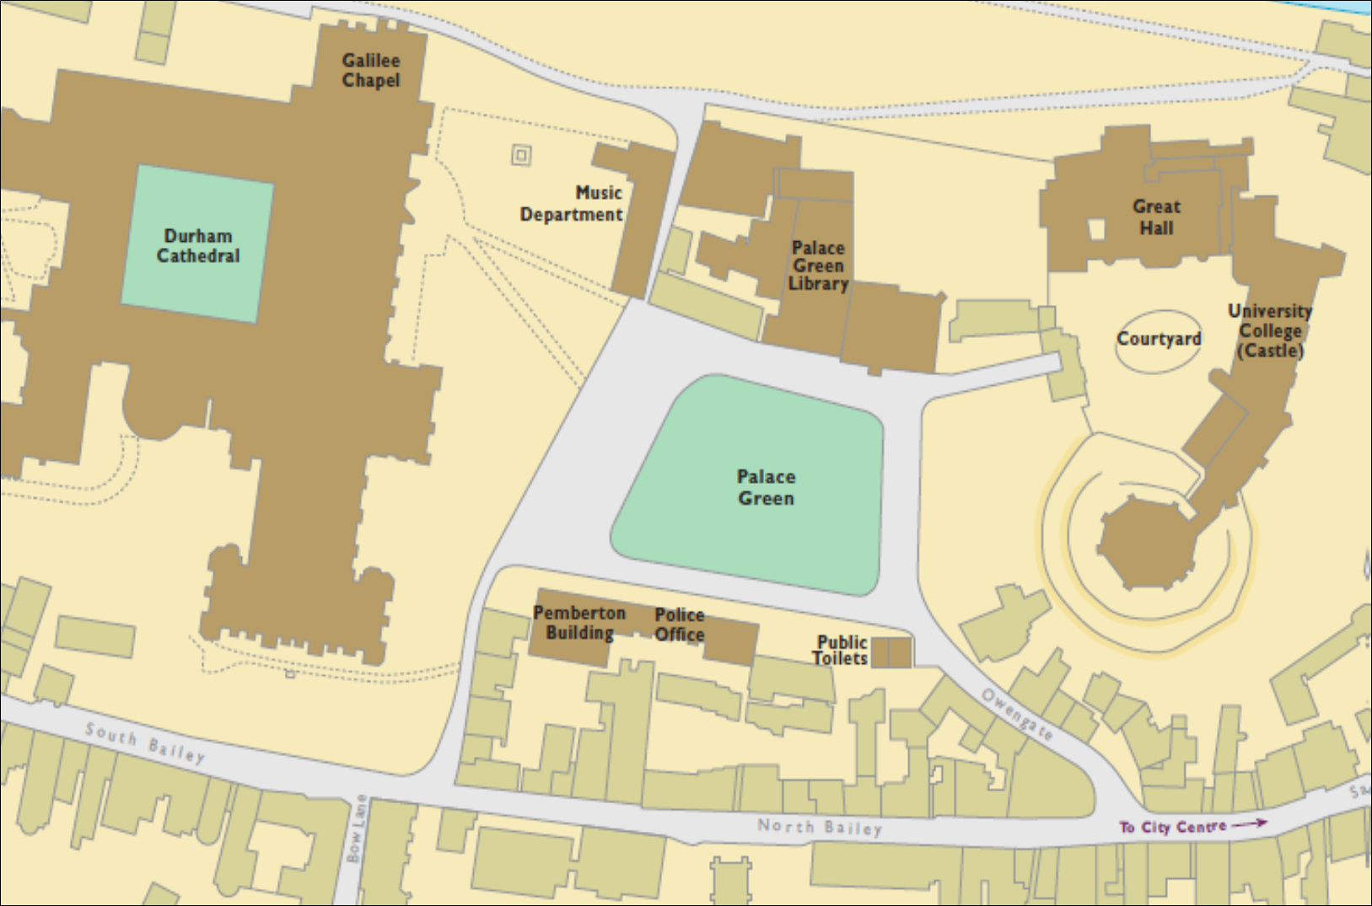
Undercroft
Robes, Registration

Undercroft
Robes, Registration

Undercroft
Robes, Registration

Graduand Procession
Toilets
+accessible and baby changing

Palace Green Library
Exhibitions,
Accessible/ Baby Changing Toilets
Palace Green Info Point
Lost property
Graduand Procession
(Graduands only)

Toilets +accessible
Teaching and Learning Centre – 15-20 minute walk
Robing, Photography & Film, Tickets, Alumni, Merchandise, Refreshments, Toilets
Left Luggage

Directions from Teaching and Learning Centre to Palace Green (on foot)
- Turn left out of TLC walking down South Road towards Whitechurch
- Cross the traffic lights onto Church Street, continue along this road
- Turn left at the traffic lights and cross Kingsgate Bridge (the Student’s Union on your right)
- Continue up the stairs and carry along up Bow Lane until you encounter the North Bailey with the side of the Cathedral in front of you
- Here, cross the road and walk up Dun Cow Lane towards Palace Green
- Durham Cathedral is on your left and Durham Castle (the Great Hall) is the far right of the green.

Directions from Teaching and Learning Centre to Palace Green (on foot - accessible)
- Turn left out of TLC walking down South Road towards Whitechurch
- Cross the traffic lights onto Church Street, continue along this road
- Continue past the Students Union and Elvet Riverside
- Turn left just after the Half Moon Inn and cross Elvet Bridge
- At the top of the street, turn left up Saddler Street, continuing up until you encounter Owengate on the right.
- Head up Owengate to Palace Green
- Durham Castle (the Great Hall) is on your right and Durham Cathedral is the far side of the green.

QUICK GUIDE: BEFORE YOUR CEREMONY DAY

Before 5pm on 17 December
Complete Congregation and Parchment registration on Banner Self Service

Before 12noon on 17 December
Contact your Faculty Office to confirm the pronunciation of your name, only if it is often mispronounced

OR
Collect tickets on the day of your ceremony from the Guest Ticket Desk in St Chad’s College
Before 17 December
Hire graduation robes with Gray & Son Robemakers

Before Arrival – Plan your day

Familiarise yourself with the key locations:
Teaching and Learning Centre - to register/ collect robes/ guest tickets/ photography
Route to Palace Green
Great Hall in the Castle (graduands)
Queue at Palace Green Information Point (guests)

Ensure you give yourself enough time:
Durham City will be busy, consider parking arrangements
There will be queues for robes/ tickets
It is a 20-minute walk from the Teaching and Learning Centre to Palace Green
Graduands must report to the Great Hall (robed) 1 hour and 15 minutes before their ceremony

QUICK GUIDE: YOUR CEREMONY DAY
Graduand to arrive at Teaching and Learning Centre
10:00 am ceremony12:00 noon ceremony3:00 pm ceremonyBy 7:30 amBy 9:30 amBy 12:30 pm

Graduand to collect robe from the Teaching and Learning Centre (access for graduands only in the robing area)
10:00 am ceremony12:00 noon ceremony3:00 pm ceremony7:30 – 8:30 am9:30 – 10:30 am12:00 – 1:30 pm

Graduand to report to the Great Hall, Castle
10:00 am ceremony12:00 noon ceremony3:00 pm ceremony8:45 am10:45 am1:45 pm

Graduate must return robe to the Teaching and Learning Centre
On the ceremony day before 5:30 pm
Guest queue to be escorted from the Information Point on Palace Green to the Cathedral
10:00 am ceremony12:00 noon ceremony3:00 pm ceremonyFrom 9:15 amFrom 11:15 amFrom 2:15 pm

Graduand to give tickets and belongings to guests before reporting to the Great Hall in Castle

Guest or graduand to collect guest tickets from the Teaching and Learning Centre
10:00 am ceremony12:00 noon ceremony3:00 pm ceremonyFrom 7:45 amFrom 9:45 amFrom 12:00 noon

Congregation Fair opening times – Teaching and Learning Centre
8:00 am – 6:00 pm

