Centre for Nineteenth-Century Studies, Durham University, Tuesday, 5th May, Durham
CNCS Postgraduate Conference Programme:
Nineteenth-Century Culture in the Flesh
Mill Hill Lane, Durham University

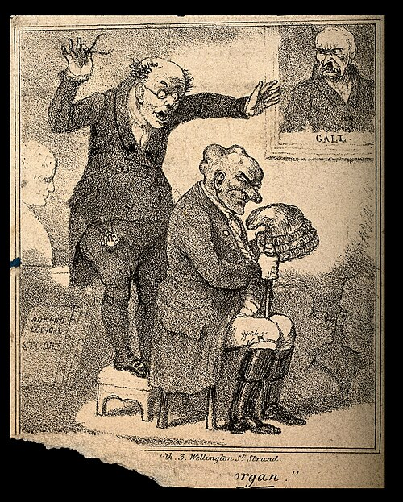
Robert Seymour (1798-1836), A phrenologist examining a man's characterful head

10am: Welcome Dr James Koranyi (Durham)

10.15 – 11.15: Keynote Prof. Carrie Vout (Cambridge), Antiquity incarnate? Nineteenth-century encounters with classical sculpture

11.15-12.30: Panel 1
Bori Papp (Northumbria), Costume as Repositories of Knowledge: Mapping the Carl Rosa Company’s regional networks.
John Haycraft (Oxford), Wrought from within upon the flesh: The Language of Physiognomy in Pater’s portraits.

12.30 – 1.30: Lunch

1.30 – 2.45: Panel 2
James Inkster (Newcastle), Criminally Old Flesh: William Thackeray’s Berry London (1844).
Taylor Moore (Oxford), The Breaking up of Laws: Sexual Mythology and the Politics of Transgression in Alfred Tennyson’s Idylls of the King.

2.45-3.45: Oriental Museum with Prof. Jonathan Saha (Durham)

4-4.30: Close and Conclusion, Shio Mitsuhashi (Durham) and Ben Thompson (Northumbria)

Speakers and Abstracts:
Panel 1:
Bori Papp, Costume as Repositories of Knowledge: Mapping the Carl Rosa Company’s regional networks.
Abstract:
The Carl Rosa Opera Company toured England, Scotland and Ireland with operas aimed particularly towards regional audiences for nearly ninety years. Their success was enabled by networks that spanned the whole country, consisting of suppliers, critics, and local performers. This paper focuses mainly on industry networks, presenting two case studies on how the Carl Rosa sourced their costumes and what this can tell us about the dynamics of taking grand opera on the road in the late nineteenth century.
Though there are no extant costumes, my argument is strongly rooted in archival research. The Carl Rosa is known to have maintained a working relationship with Auguste et Cie, a costumier who is credited on at least one of their nineteenth-century programmes. Auguste et Cie was run by Patience Harris, the sister of Augustus Harris, who worked as a manager for the Carl Rosa for several years. Meanwhile, a trombone part for Gounod’s Romeo and Juliet is bound in what appears to be a fragment of a box from Grant Bros, a department store and fabric retailer based in Croydon. A postage stamp on the same box suggests a link with Brand and Mollison, a Glasgow-based dyer and dry-cleaner.
Mapping connections like these can provide useful insights into the professional relationships that underpinned the Carl Rosa’s “operatic machine”, highlighting the stories of artistic collaborators who have historically been underrepresented in research. Taking objects from the archive allows us to establish a tangible connection with the past and relate to the people whose hands they passed through.
Biography:
Bori Papp is a costume maker turned theatre historian, currently working towards a PhD on the performance practices of the Carl Rosa Opera Company at Northumbria University. Her past research on the Ballets Russes has revolved around questions of identity and the community-building potential of theatrical performance. More broadly, she is also interested in the intersection of private and public spheres, the marginalised stories of those working backstage, and challenging traditional divides between the popular and the elite.
Bori is an academic and a creative in equal measure, with a particular interest in the space where the two intersect. Accordingly, she aims to approach history as a discipline that can take place through a range of media, including in the archive, on stage, and on screen.

John Haycraft, Wrought from within upon the flesh: The Language of Physiognomy in Pater’s portraits.
Abstract:
This paper will explore the prominent role of physiognomic language across Walter Pater’s
oeuvre, arguing that much of his critical portraiture reflects a broader cultural interest in the
possibility of reading character in the flesh. Although Pater’s engagement with nineteenth-century science is well-documented, little attention has yet been paid to Pater’s indebtedness to the discourse of physiognomy in particular, which he defines as the belief that “not love only, but every other affection of man’s soul, looks out very plainly from the window of the eyes.” While Pater at times invokes physiognomy explicitly, he more often absorbs its interpretive logic, whereby the visible surface of the body discloses interior states, histories, and “types.”

Drawing on both early essays such as Winckelmann and later works such as Marius, this
paper will argue that Pater’s descriptive method invites readers to encounter various of his
“cases” as embodied presences, whose inner lives are, as we read in the La Gioconda
passage, “wrought from within upon the flesh.” In attending closely to faces, gestures, and other physical signs, Pater consistently treats the body as a site of critical interpretation, where surface becomes the medium through which culture and character are revealed. Recovering the clear influence of physiognomic discourse over Pater’s critical portraiture not only allows us to develop a fuller account of his interpretive practice, but also to sharpen both our understanding of the role which contemporary science played in high-Victorian criticism and of how culture itself came to be meaningfully encountered in the flesh during this period.

Biography:
John Haycraft is currently reading for the MSt. in English (1830-1914) at Brasenose College,
Oxford with a dissertation on Walter Pater. He is currently serving as a research assistant on
two forthcoming monographs on nineteenth-century aesthetics

James Inkster, Criminally Old Flesh: William Thackeray’s Berry London (1844).

Abstract:

At the end of the nineteenth century, literary characters with aged bodies were often depicted as criminals or even monsters living on the margins of society. Karen Chase, for example, explains how aged “men and women” were frequently represented as “witches and vampires” in fin-de-siècle literature (‘Senile Sexuality’ 134). In this paper, though, I argue that William Thackeray (1811-1863) was already connecting old flesh with criminals in the 1840s. Thackeray’s novel Barry Lyndon (1844) pretends to be an account of its narrator’s criminal life (written from his prison cell), and – while it makes no explicit reference to the following practice – as an eighteenth- and nineteenth-century criminal’s autobiography, Thackeray’s novel imitates a form of life writing which would sometimes be wrapped in the actual skin of its author! In Relics of Death in Victorian Literature and Culture (2015), Deborah Lutz describes the practice of “anthropodermic bibliopegy” – the binding of books with human flesh – and she notes that most “volumes” bound in this manner “involved the skin of criminals”; they “were either autobiographies of the executed person […] or accounts of their crimes, trials, and deaths” (97-98). But, like many fictional and non-fictional autobiographers, Barry Lyndon is also an old man when he ‘writes’ his record of wrongdoing; “I’m writing now,” states Barry, “in my gouty old age” (248). I therefore suggest that Thackeray’s novel anticipates, or perhaps helps to establish, the late-Victorian conflation of elderly bodies with those of criminals or monsters.

Biography:
James Inkster studied English at the University of Cambridge (2017-2020) and he recently completed his PhD in nineteenth-century literature at Newcastle University (2022-2026). His thesis focused on the fictional autobiography and the survival of aged selves and species in the nineteenth century, and he is now expanding that work into a monograph. He has presented papers at the CNCS Postgraduate Conference (2024, 2025), at the ISSN conference (2024), at Newcastle’s international symposium Re/Writing Crisis (2024), and he has published an article on Gothic literature and Victorian Egyptology in the Durham Postgraduate English journal (2024).

Taylor Moore, The Breaking up of Laws: Sexual Mythology and the Politics of Transgression in Alfred Tennyson’s Idylls of the King.
Abstract
In the Idylls of the King, Alfred Tennyson reworked Arthurian myth for a Victorian audience, imbuing it with a degree of psychological realism not present in sources such as Malory and updating its content to reflect Victorian social concerns. This is visible especially in his account of Guinevere’s adultery, an action traditionally read as the action responsible for Arthur’s decline and fall in the Idylls. But the account of Guinevere presented is fraught with an ambiguity, simultaneously admitting and obscuring contradiction, allowing for a nuanced locus of blame. Her presentation is reflective of an increasing interest in sexuality as a subject in literature during the period, not merely as transgressive but as an embodied act. As scientific development pointed towards an increasingly materialistic and abstract account of nature, sexual interaction offered a locus both embodied and subject to agency, hence to moral scrutiny. Its presentation thus served as opportunity to both reinforce traditionalist social norms and highlight the destructive potential of their violation, all while maintaining a pretence of free and informed moral agency. Tennyson’s account of Guinevere does largely serve this purpose, but also draws into question the objectivity of that same framework. The work allows the Queen to voice credible rationales for her actions multiple times, such as in “Lancelot and Elaine”; and the speaker refuses to condemn her in his own words in “Guinevere,” following her disgrace. Studying these features will bring new light to Victorian understanding of both received mythology and contemporary gender politics.
Biography:
Taylor Gray Moore was born in Vancouver, Canada, in 1992. He read his undergraduate degree in Canadian literature at McGill University, graduating in 2018, and is currently reading for an MSt in English (1830-1914) at the University of Oxford. Between these two periods of study, he published three collections of poetry. His areas of interest include myth reception, escapist fantasy as social comment, and the history of poetry.

