Infinity: An Internship Programme for Autistic Students

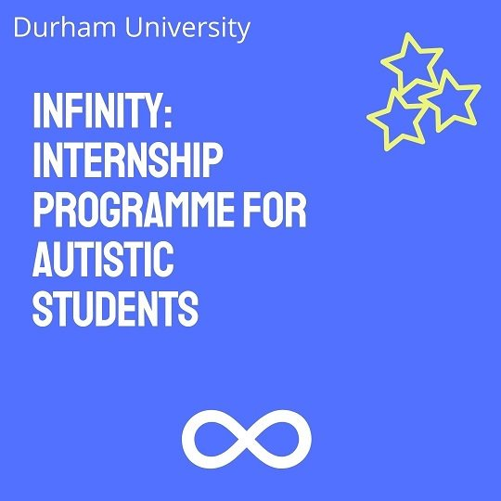

Following the success of last year’s inaugural programme, Durham University is delighted to announce the launch of Infinity: Internship Programme for Autistic Students, an innovative work experience programme for autistic students, for 2022-2023. Then programme will continue to bring together highly sought-after Durham students with progressive and forward-thinking employers, creating meaningful internships, as part of a supportive programme.
We would be delighted if you would consider becoming one of our employer partners in this programme. The benefits of offering an internship to one or more of our autistic students include:
- access to a pool of untapped, diverse talent
- increase the morale and retention of your staff
- develop strong partnership relations with Durham University
- promote diversity of thought and problem solving
- reflect the diversity of your clients and communities
- An intern within your organisation to complete a project or piece of work
Interns' salaries are funded by Durham University (in accordance with the terms and conditions of the programme), so your organisation would benefit from a Durham University student (referred to as interns hereafter), to undertake a meaningful project with your organisation, at no cost to you.
Some key points:

- Internships can be 4 or 8 weeks in length (full time or part time)
- Each organisation can request host up to 4 interns (to be agreed between the University and the organisation)
- Internships can be remote or in person. We strongly recommend that ‘in person’ projects are developed so that they can be undertaken online should the need arise. You may wish to consider a hybrid model as this was a highly successful model last year.
- Internships should take place during the University summer vacation (24th June – 24th September)
- Interns are employed by the host organisation
- Training and regular support provided specifically for participating organisations by Disability Support and Careers & Enterprise, Durham University.
- There is a fixed sum of funds available. Funding in principle will be allocated fairly and in the best interests of the student cohort.

How does the scheme work?

- Organisations should familiarise themselves with the Terms and Conditions
- Organisation expresses interest in hosting an internship for an autistic student (note: Internships can last either 4 or 8 weeks)
- Organisation submits a proposal for a work project
- Funding allocated to organisation, in principle
- Organisation attends training session run by Disability Support
- Recruitment of Durham University autistic student (intern) to internship role
- Organisation to inform Durham University programme manager of successful(intern)
- Organisation conducts eligibility to work checks
- Letter of agreement signed by host organisation and intern
- Intern to be employed and paid by the organisation (as with any temporary staff member within the organisation)
- Funds to be provided by Durham University as reimbursement
- Feedback from both the intern and host organisation required for Durham University (and may be used for case studies and marketing)

Infinity: Eligibility and Terms of Funding 2022-2023

1. Businesses:
(a) Organisations must be registered and based in the UK
(b) Eligible organisations include companies, start-ups, sole traders, and partnerships from all sectors (including the Third sector)
(c)Funding is provided for businesses to benefit from a fully paid student (known as intern) to do a work project/internship within the business. The internship can be completed virtually or in person or be based on a hybrid model.
(d) Participating businesses can apply for funds to recruit a maximum of 4 students (per organisation) through each cycle of the scheme to complete one or multiple work projects. Please note: this is not guaranteed. Businesses can propose to host up to four interns, the final amount will be decided by the programme team and will be dependent on funding levels.
2. Students:
(a) Candidates must be autistic students from Durham University
(b) Once an intern has completed a fully paid work project, they cannot apply for another fully funded work project with the same organisation, without prior permission from the Programme team.
(c) Interns will be employed and paid by the host organisation and should be treated as a member of the organisation during their internship.
(d) Interns will be required to provide feedback on their experience, as outlined within the terms of the funding
3. Programme Structure:
Internships will be either:
4 weeks (or FTE) in duration. Based on a 35 hour week.
or
8 weeks (or FTE) in duration. Based on a 35 hour week.
Internships may be part time, with prior agreement of the programme team, intern and host organisation, this must be arranged in advance.
Internships should start no later than 1st July 2023, unless agreed in advance with the Programme team.
4. Reimbursement/pay for interns
Each intern will be paid as follows:
External hosts/organisations (non Durham University)
4 week (FTE) internship - £1610 (based on a 35 hour week, £11.50 per hour).
8 week (FTE) internship - £3220 (based on a 35 hour week, £11.50 per hour).
Interns should accrue holiday entitlement during this time as it is not included within this hourly rate (externally hosted/non Durham University based internships only).
Durham University host departments
Rates of pay will be based on the Durham University ‘Casual Intern’ rate of pay, and should adjust as pay rates adjust, expected in May 2023 and August 2023. Pay rates can be found here: Reward Hub - Main Pay Scale 01-08-22.pdf - All Documents (sharepoint.com). Holiday pay is then added to these rates so that an intern would benefit from this automatically.

4. Management of the Programme:
The University’s nominated Programme Management team (contact via: autism.programme@durham.ac.uk) are the main point of contact for the host organisation. The Programme team will ensure that the programme and the projects on offer are advertised widely via our Student Services Portal, social media and weekly email bulletin, as well as answer any queries the organisation might have.
Organisations will receive applications directly (from students who have had their eligibility for the programme confirmed by our Disability Support team), therefore allowing them the opportunity to manage their own recruitment process. Once the organisation has shortlisted candidates for an internship, they will be responsible for interviewing candidates and managing all aspects of the recruitment process. Support from the Programme Manager is available on request.

5. Funding and payment:
Each intern under the Programme must be paid as outlined in the terms above (Section 2: Students).
The organisation will pay the intern the total amount. Durham University holds the funding and will transfer the funds to the organisation within a pre-determined number of weeks of the internship starting and in accordance with the terms of the programme.
Please contact the Programme Management team with any queries: autism.programme@durham.ac.uk

Internship Proposal Form
Please complete this form, providing full details of the internship.
Please return completed forms to autism.programme@durham.ac.uk
Queries: Contact Work Experience Development Manager (Victoria Cawkwell): autism.programme@durham.ac.uk

Organisation Information
Organisation name
Named contact & job title
Email
Phone
Business Address
All organisations taking part in this programme must undertake employer training. Please confirm that this is acceptable to you. Note: this will be tailored to the needs of your organisation.

Organisation summary:

Please provide some information (including the business sector) about your area of work. Please ensure it is useful for a student

Internship title: _____________________________

Internship brief/outline
Preferred working arrangements?
Home/office/hybrid model

Project Timings (please select one only)
Duration (select one only) | 4 weeks
 | 8 weeks
Hours (select one only) | Full time
 | Part time

Preferred Start Date/Timescale
Note: Summer vacation 24.06.23 - 24.09.23. Internships must have started by 1.07.23, unless agreed with the Programme team.

Person specification

Please list the key skills and / or experience you are looking for

Recruitment

Projects will be advertised to potential interns via Durham University vacancy portal. Intern applications will be by CV and covering letter
Please outline how you would like to receive applications. If online please provide the link, if via email then please provide the email address
Please specify application deadline

Health and Safety
Please supply your Public Liability Insurance number
Please also email a copy of the certificate to autism.programme@durham.ac.uk

Please supply your Employer’s Liability Insurance number
Please also email a copy of the certificate to autism.programme@durham.ac.uk

Please give a brief summary of your
a) Organisation induction
and
b) Health & safety induction for interns
Please confirm that you have undertaken a risk assessment for the project (or will do so in advance of the project starting)
The internship
Please confirm that you will take responsibility for the employment of the intern (including conducting Eligibility to Work checks, providing a temporary contract, paying the intern*)
*You will be reimbursed by Durham University
Have you had training and/or experience in supporting autistic students? Please describe/explain your level of knowledge.
Please note: this is not a pre-requisite. We ask this so that we can best support you in advance of, and during, the programme commencing.

The programme support team will keep in touch during the internship to monitor progress, check that all is going well, and the satisfaction of both parties. We will request a short impact statement from the employer at the end of the work project and a case study from the intern.
Signed: ………………………………………... (Organisation)
Date:
Durham University Data Protection Policy can be viewed here: https://www.dur.ac.uk/ig/policies/dppolicy/

Organisations can request funds for up to 4 interns, however we cannot guarantee that originations will be allocated the total they request/propose. Funds will be allocated according to a number of factors and decided by the programme team.
considering the most up to date Government guidelines at the time of delivery
The terms and conditions are contained within this document, and you can request a copy at any time
Recruitment to be managed by the organisation
Please ensure you use ‘Casual Intern’ and not ‘Casual Intern 2’. Please ask if you have any questions.
At the business’s discretion, in line with the UK Government’s most recent Covid-19 guidelines

